# Operators Associativity and Precedence Assignment

1. Use operator associativity, evaluate the folowing expressions and predict the output
   1. x = 34 + 12/4 – 56

Ans) -19

* 1. 12 + 3 - 4 / 2 < 3 + 1

Ans) 0(boolean false)

* 1. (2 + (3 + 2) ) * 10

Ans) 70

* 1. 34 + 12/4 – 45

Ans) -8

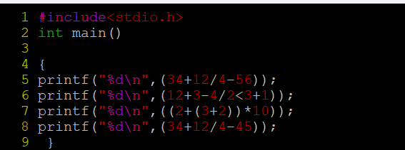

1. Rewrite the following expressions with improved readability
   1. age < 18 && height < 48 || age > 60 && height > 72
   2. char name value
   3. char $name

Ans) a) age<18|| age>60 && height<48 || height>72

b) char name_value

c) char name

1. Predict the value of a after each statement.

int main(void)

{

int i = 10;

char a = 'd'; 🡺100

a += 10; 🡺 110

a *= 5; 🡺550

a /= 4; 🡺 137

a %= 2; 🡺 1

a *= a + i; 🡺11

**return** 0;

}

1. Consider a = 12, b = 3, predict the output of the following .
   1. (a>100) && (b<10) 🡺false
   2. (a==4) && (b==2) 🡺false
   3. (a==11) && (a++) 🡺false
2. Consider a = 10, b = 11, predict the output of the following .
   1. (a>10) || (b<10) 🡺false
   2. a || 12.12 🡺true
   3. a || b🡺true
   4. !(a > 5)🡺false
3. Consider int age = 10, height = 45, year = 2000; Predict the output of the following.
   1. (age < 12 && height < 48) || (age > 65 && height > 72)🡺true
   2. (year % 4 == 0 && year % 100 != 0 ) || (year % 400 == 0);🡺true